|  |  |  |
| --- | --- | --- |
| **Sponsorship**  **Category** | **Amount /** total value of sponsorship | **Benefits** |
| **Gold**  Sponsors | $800 and above | * Logo in the Mayor’s monthly column in the *Tennant and District Times* to acknowledge support * Logo at top of Council banner, present at all Australia Day activities, to acknowledge support * Allowed to bring a maximum of two company or organisational banners or promotional materials on the day * Coupon for Australia Day morning ceremony breakfast for two * Prominent recognition in the lead up to and after the event in the local newspaper, BRC community board and social media * Prominent recognition on the day of celebration * A Certificate of Appreciation from the Australia Day Council NT and Barkly Regional Council |
| **Silver**  Sponsors | $500 - $799 | * Thank you mention in the Mayor’s monthly column in the *Tennant and District Times* to acknowledge support * Logo in the middle of Council banner, present at all Australia Day events, to acknowledge support * Allowed to bring one company or organisation banners or promotional material on the day * Prominent recognition in the lead up to and after the event in the local newspaper, BRC community board and social media * Prominent recognition on the day of celebration * A Certificate of Appreciation from the Australia Day Council NT and Barkly Regional Council |
| **Bronze**  Sponsors | $200 - $499 | * Thank you mention in the Mayor’s monthly column in the *Tennant and District Times* to acknowledge support * Logo towards bottom of Council banner, present at all Australia Day activities, to acknowledge support * Recognition in the lead up to and after the event in the local newspaper, BRC community board and social media * Recognition on the day of celebration * A Certificate of Appreciation from the Australia Day Council NT and Barkly Regional Council |
| **Iron**  Sponsors | Below $200 | * Thank you mention in the Mayor’s monthly column in the *Tennant and District Times* to acknowledge support * Logo at the bottom of Council banner, present at all Australia Day activities, to acknowledge support * Recognition in the lead up to and after the event in the local newspaper, BRC community board and social media * Recognition on the day of celebration * A Certificate of Appreciation from the Australia Day Council NT and Barkly Regional Council |

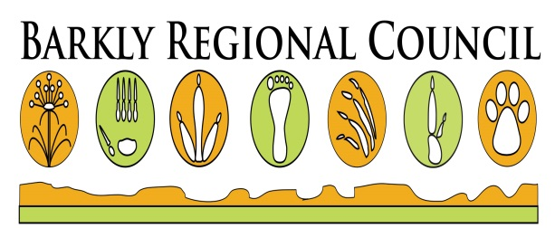

**2019 Australia Day Celebrations at Lake Mary Ann**