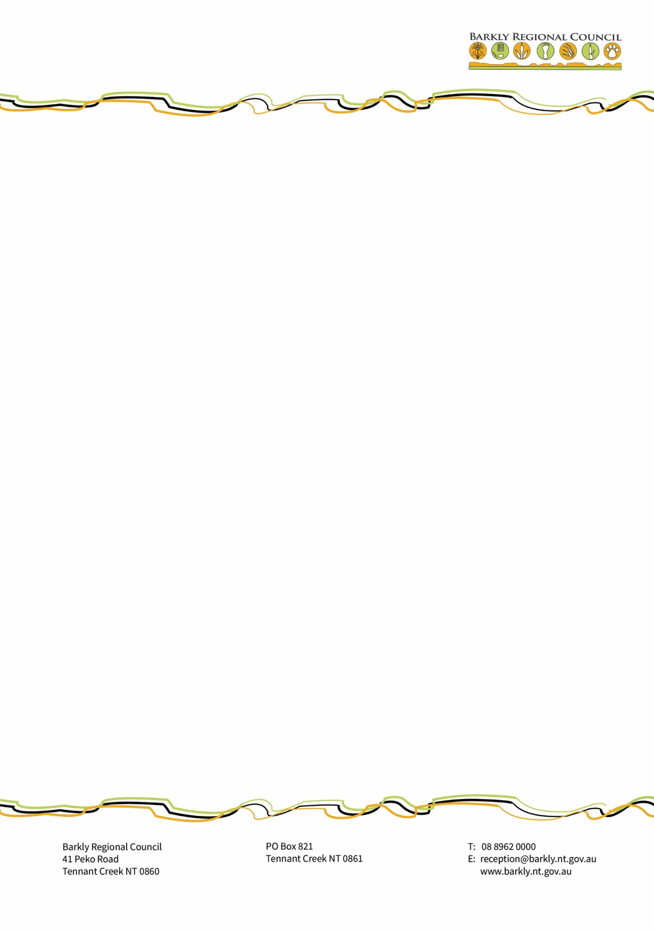

**CALL FOR EXPRESSION OF INTEREST: JUNO**

**Barkly Regional Council** is inviting **Expressions of Interest** (EOI) for lease of NT Portion 1918 (Section A below), formerly known as Juno Horse Farm, near Tennant Creek. This freehold property totals 1020hectares and is located 10kms from Tennant Creek. The land available for lease is marked “A” on the image below, and is 770ha.

For any further questions or to organise inspections please contact Sid Vashist at Barkly Regional Council on 0408 368 186.

Offers should clearly outline:

1. The nature of the development that applicant plans to undertake
2. Available details of the impact of the development, including economic and environmental
3. The financial and other conditions of the lease

Please return the EOI marked “Juno in confidence” via email to [Sid.Vashist@barkly.nt.gov.au](mailto:Sid.Vashist@barkly.nt.gov.au), or by mail to Director of Corporate Services, Barkly Regional Council, P.O Box 821, Tennant Creek, NT 0861, or hand delivered in a sealed envelope to 41 Peko Rd, Tennant Creek.

All offers should be sent by close of business on the 11th February 2022.

Map of the property, available land is marked “A”

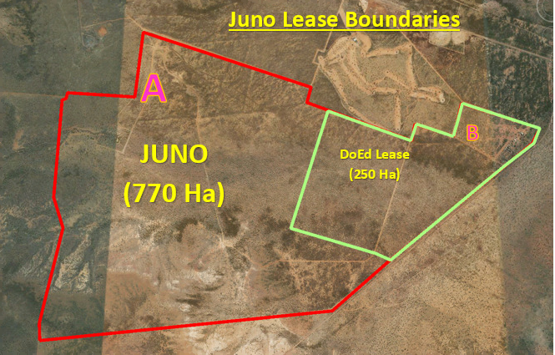

**Declaration**

By submitting an expression of interest, the applicant:

• warrants to Barkly Regional Council that:

* the information contained in its application is accurate and complete as at the date on which it is submitted and not by omission misleading, and may be relied on by the Barkly Regional Council in determining whether or not to select the applicant;
* the proposed project complies with all the legal compliance requirements and will obtain the permits/clearances necessary from Commonwealth and Northern Territory Government, respectively;
* undertakes to promptly advise Barkly Regional Council if it becomes aware of any change in circumstances which causes the information contained in its application to become inaccurate or incomplete in a material respect;
* acknowledges that the Barkly Regional Council will rely on the above warranty and undertaking when evaluating the application;
* acknowledges that the Barkly Regional Council may elect to remove an applicant at any stage as a result of material changes to the information presented in its application;
* acknowledges that the Barkly Regional Council may suffer loss or damage if the applicant breaches the above warranty and undertaking; and
* is taken to have accepted the guidelines and these terms and conditions.

**Name of Applicant: ………………………………………………**

**Signature: ………………………………………………**

**Date signed: ………………………………………………**



